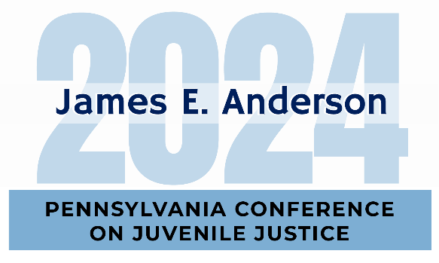

Call for Presentations

November 6 - November 8, 2024
Hilton Harrisburg

Are you enthusiastic about enhancing Pennsylvania's juvenile justice system with your professional expertise? Do you want to spread your message to 1,000 of your colleagues? We cordially welcome submissions for the 2024 James E. Anderson Pennsylvania Conference on Juvenile Justice, held on November 6-8, 2024, at the Hilton Harrisburg.
The conference focus will be rooted in responsivity in the Pennsylvania juvenile justice system. Each year the conference includes workshops that highlight practices, programs, and initiatives which exemplify the various components of Pennsylvania's Balanced & Restorative Justice mission and the Juvenile Justice System Enhancement Strategy. Workshops are to encourage dialogue among professionals, spark imagination, and discover solutions to our system's ongoing challenges.
This year’s conference workshops will take place on Thursday, November 7, 2024. Themes may include but are not limited to professional alliance skills, diversity and/or inclusion, stakeholder engagement, and responsivity factors. Interested parties should complete and submit the following presentation proposal form by Friday, May 3, 2024.
The 2024 James E. Anderson Pennsylvania Conference on Juvenile Justice is sponsored by the Juvenile Court Judges' Commission, the Pennsylvania Council of Chief Juvenile Probation Officers, the Pennsylvania Commission on Crime and Delinquency, and the Juvenile Court Section of the Pennsylvania Conference of State Trial Judges.
Presentation Proposal Form
2024 James E. Anderson
Pennsylvania Conference on Juvenile Justice

Proposed title of workshop:
Click here to enter text.
Brief description of workshop content and methodology: (100 words or less – please describe the learning objectives, content, and method of delivery for your presentation, e.g., case study review, interactive exercises, etc.)
Click here to enter text.
Facilitator #1 name and professional title: Click here to enter text.
Facilitator #1 agency/organization and address: Click here to enter text.
Facilitator #1 email address: Click here to enter text.
Facilitator #2 name and professional title: Click here to enter text.
Facilitator #2 agency/organization and address: Click here to enter text.
Facilitator #2 email address: Click here to enter text.
For additional facilitator information, please see page three.

TO BE CONSIDERED FOR APPROVAL, PLEASE RETURN PACKET, COMPLETED IN FULL,
BY FRIDAY, MAY 3, 2024, TO:

Stephanie Black Adrianne Robbins
Juvenile Court Judges’ Commission Juvenile Court Judges’ Commission
Phone: 717-317-3874 Phone: 717-216-7267
Email: stepblack@pa.gov Email: adrobbins@pa.gov

Please Note: Up to two facilitators from each selected workshop will be our guests during the three-day conference with conference registration fees waived and meals provided. Facilitators will be responsible for their own lodging and travel expenses.

Presentation Proposal Form
2024 James E. Anderson
Pennsylvania Conference on Juvenile Justice
Additional Facilitators

Facilitator #3 name and professional title: Click here to enter text.
Facilitator #3 agency/organization and address: Click here to enter text.
Facilitator #3 email address: Click here to enter text.

Facilitator #4 name and professional title: Click here to enter text.
Facilitator #4 agency/organization and address: Click here to enter text.
Facilitator #4 email address: Click here to enter text.

Facilitator #5 name and professional title: Click here to enter text.
Facilitator #5 agency/organization and address: Click here to enter text.
Facilitator #5 email address: Click here to enter text.

Facilitator #6 name and professional title: Click here to enter text.
Facilitator #6 agency/organization and address: Click here to enter text.
Facilitator #6 email address: Click here to enter text.

Facilitator #7 name and professional title: Click here to enter text.
Facilitator #7 agency/organization and address: Click here to enter text.
Facilitator #7 email address: Click here to enter text.

Facilitator #8 name and professional title: Click here to enter text.
Facilitator #8 agency/organization and address: Click here to enter text.
Facilitator #8 email address: Click here to enter text.

