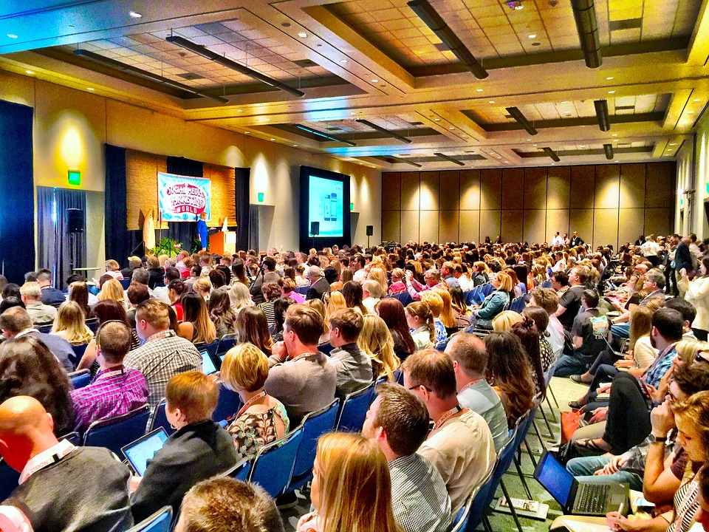

Call for Presentations
The 2023 James E. Anderson
Pennsylvania Conference on Juvenile Justice

November 1 - November 3, 2023
Hilton Harrisburg

The 2023 James E. Anderson Pennsylvania Conference on Juvenile Justice, sponsored by the Juvenile Court Judges' Commission, the Pennsylvania Council of Chief Juvenile Probation Officers, the Pennsylvania Commission on Crime and Delinquency, and the Juvenile Court Section of the Pennsylvania Conference of State Trial Judges will be held November 1-3, 2023, at the Hilton Harrisburg.

Each year the Conference includes workshops that highlight practices, programs and initiatives that exemplify best-practices related to the various components of Pennsylvania's Balanced & Restorative Justice mission and our Juvenile Justice System Enhancement Strategy (JJSES). This year’s workshops will take place on Thursday, November 2, 2023. The workshops will be 90 minutes in length and will be repeated via morning and afternoon sessions.

We enthusiastically welcome submissions for presentations. Interested parties can complete and submit the following presentation proposal form. Please note that up to two facilitators from each selected workshop will receive free Conference registration and meals (facilitators are responsible for their own travel and lodging expenses).

Submissions for presentations are due by Friday, April 28, 2023, and can be directed to Leo J. Lutz, Director of Policy and Program Development, at lelutz@pa.gov.
Presentation Proposal Form
The 2023 James E. Anderson
Pennsylvania Conference on Juvenile Justice

PLEASE RETURN THIS FORM AND ATTACH ANY WORKSHOP DESCRIPTIVE MATERIALS
BY FRIDAY, APRIL 28, 2023 TO:

Leo J. Lutz, Director of Policy and Program Development
Juvenile Court Judges’ Commission
Phone: 717-705-2290
Email: lelutz@pa.gov

Proposed title of workshop:
Click here to enter text.
Brief description of workshop content and methodology: (100 words or less – please describe the learning objectives, content, and method of delivery for your presentation, e.g., case study review, interactive exercises, etc.)
Click here to enter text.
Name of principal facilitator: Click here to enter text.
Title: Click here to enter text.
Agency/organization and address: Click here to enter text.
Telephone: Click here to enter text.
Email address: Click here to enter text.
Brief Bio of facilitator: Click here to enter text.
Co-facilitator (If applicable):
Name: Click here to enter text.
Email address: Click here to enter text.
Brief Bio of co-facilitator(s): Click here to enter text.
Please Note: Up to two facilitators from each selected workshop will be our guests during the three-day conference with conference registration fees waived and meals provided. Facilitators will be responsible for their own lodging and travel expenses.

